Fall Festival for Muslims
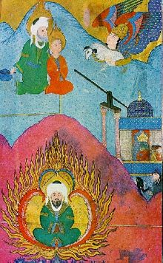
The festival of Id al-Adha will begin on October 4 in U.A.E. because that is when the crescent moon rises. In America it will be Oct 5. Muslims all over the world will be leaving on a trip to Saudi Arabia. Why? Because there is a legend that Ibrahim dreamed that Allah (god) wanted him to sacrifice his son. Allah tested Ibrahim’s faith. People travel to Saudi Arabia, where the story happened.
The children at home celebrate this holiday. First they bow 4 times, 2 times, 3 times. They pray to Allah when they bow. After that they celebrate with balloons, eat cake, and open presents. Kids see movies about their parents’ trip. That is why we celebrate Id al-Adha.

