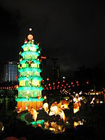
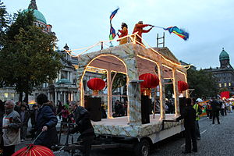
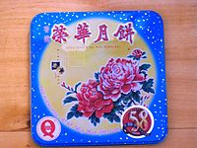
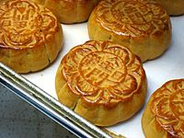
Chinese Harvest Moon Festival
People celebrate the moon festival annually in Vietnam and China. Also in U.S.A some people celebrate this festival if they have families who come from China or Vietnam.
It is not on the same day every year, but it is on the first full moon of the fall. Some Americans also celebrate the full moon, but they don’t use the same decorations or foods.
Moon cakes have Chinese words on them. Inside them are red beans and dried eggs. Some have white food in the center, and they don’t have any flavor.
People have parades in big cities. They put decorations on top of a trailer. It looks like a boat, but it has wheels. It is called a float.

